

Web Technologies and Security
CSC-40046
School of Computing and Mathematics
Keele University
UK, 2024

Date of submission: 8th May, 2024
Name: Jyothesh Karnam
Student ID: 23032448
Module leader: James Rooney

Design

- Entity Relationship diagram Representing the Database Design

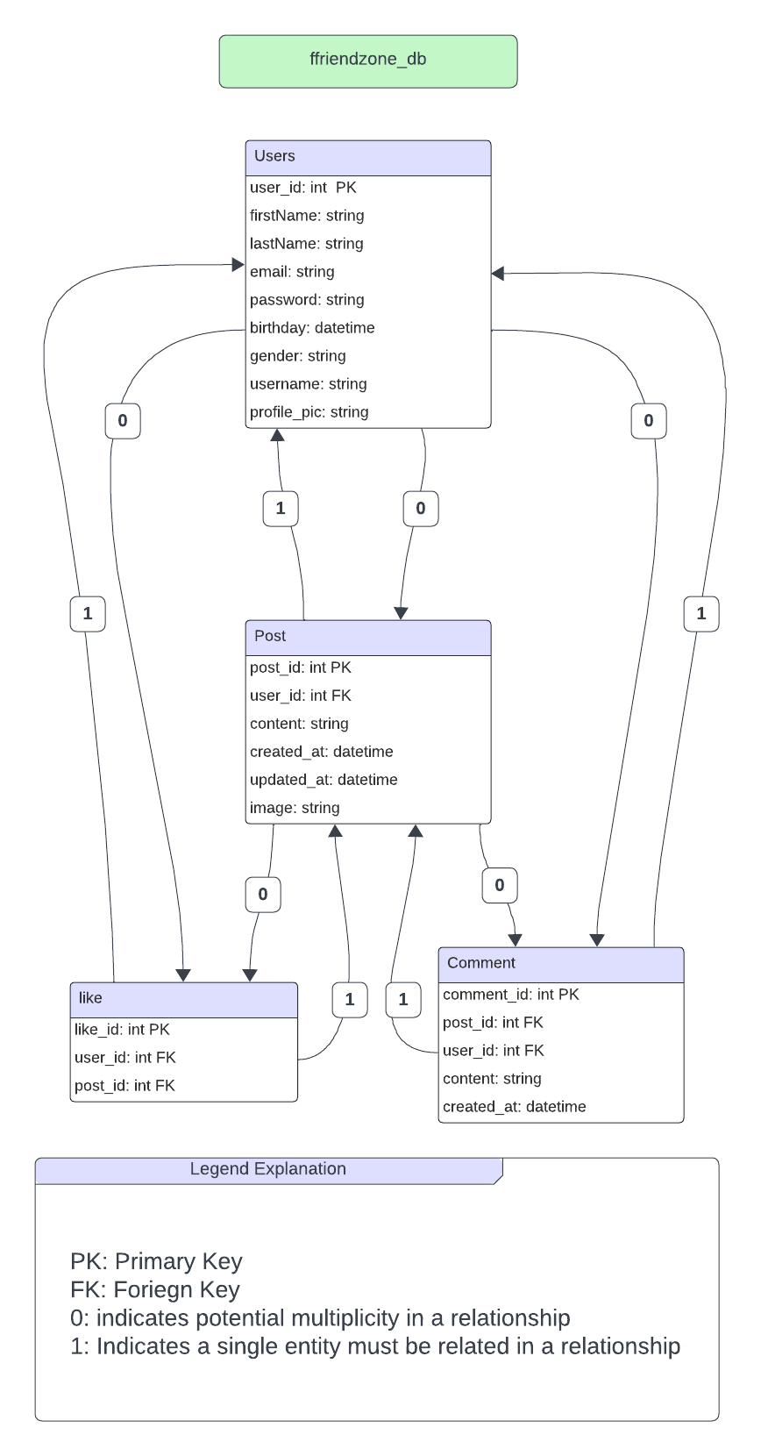

- A site map that clearly shows the structure of your site and details the filenames of all the pages you plan to create and how they relate to one another. This does not need to show all included php files, but it should show all of the pages a user can visit.

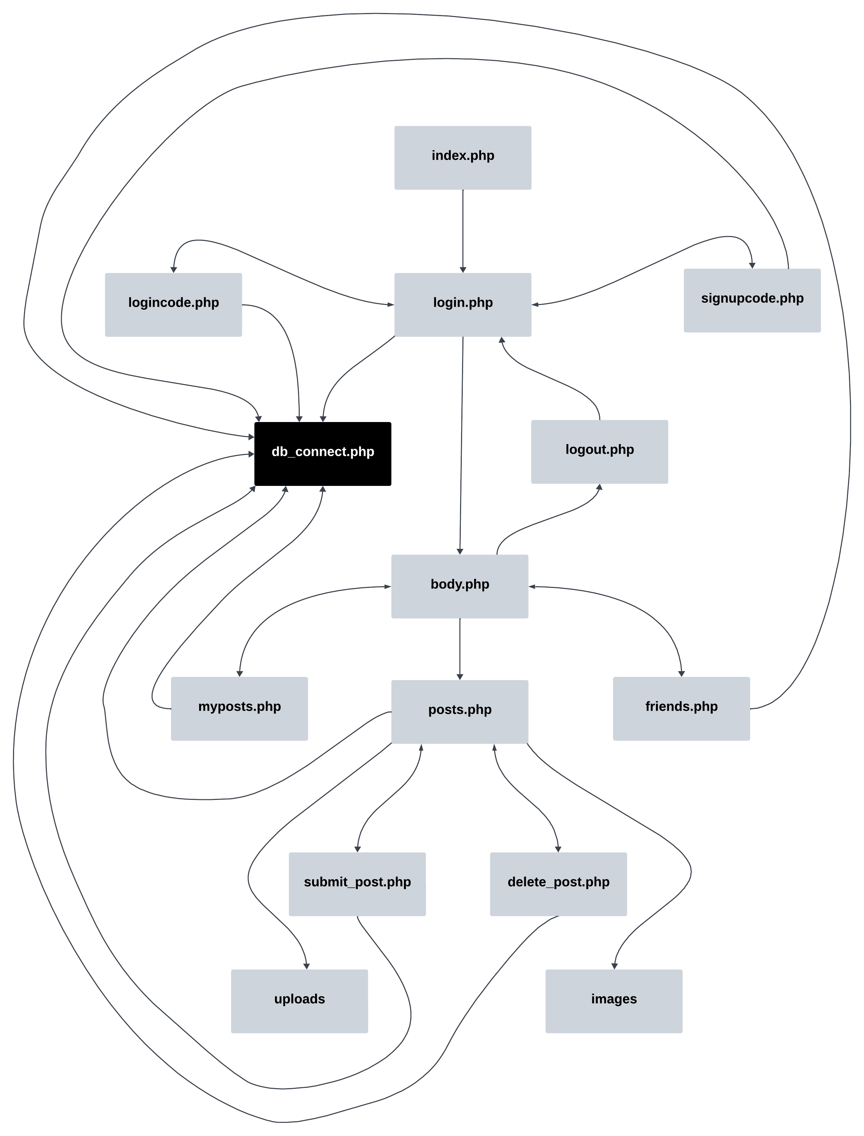

- A set of CREATE TABLE statements showing the field types for each table along with INSERT queries if any initial data is required to set up the site
- -- phpMyAdmin SQL Dump
- -- version 4.6.6deb5ubuntu0.5
- -- https://www.phpmyadmin.net/
- --
- -- Host: localhost:3306
- -- Generation Time: May 09, 2024 at 01:14 PM
- -- Server version: 5.7.42-0ubuntu0.18.04.1
- -- PHP Version: 7.2.24-0ubuntu0.18.04.17

- SET SQL_MODE = "NO_AUTO_VALUE_ON_ZERO";
- SET time_zone = "+00:00";

- /*!40101 SET @OLD_CHARACTER_SET_CLIENT=@@CHARACTER_SET_CLIENT */;
- /*!40101 SET @OLD_CHARACTER_SET_RESULTS=@@CHARACTER_SET_RESULTS */;
- /*!40101 SET @OLD_COLLATION_CONNECTION=@@COLLATION_CONNECTION */;
- /*!40101 SET NAMES utf8mb4 */;

- --
- -- Database: `y0k96`
- --

- -- --------------------------------------------------------

- --
- -- Table structure for table `comments`
- --

- CREATE TABLE `comments` (
- `comment_id` int(11) NOT NULL,
- `post_id` int(11) DEFAULT NULL,
- `user_id` int(11) DEFAULT NULL,
- `content` text,
- `created_at` timestamp NOT NULL DEFAULT CURRENT_TIMESTAMP
- ) ENGINE=InnoDB DEFAULT CHARSET=utf8mb4;

- --
- -- Dumping data for table `comments`
- --

- INSERT INTO `comments` (`comment_id`, `post_id`, `user_id`, `content`, `created_at`) VALUES
- (1, 17, 19, 'czxc', '2024-05-02 19:01:37'),
- (2, 17, 19, 'aaaaa', '2024-05-02 19:01:42'),
- (3, 18, 19, 'svdsdv', '2024-05-02 19:11:21'),
- (4, 18, 19, 'svdsdv', '2024-05-02 19:11:47'),
- (5, 7, 19, 'heelo script', '2024-05-02 19:32:39'),
- (6, 7, 19, 'heelo script', '2024-05-02 19:33:02'),
- (7, 7, 19, 'heelo script', '2024-05-02 19:33:43'),
- (8, 20, 20, 'fsbsfb', '2024-05-02 20:02:12'),
- (9, 20, 20, 'vxzv', '2024-05-02 20:02:14'),
- (10, 20, 20, 'hey we are ', '2024-05-02 20:02:27'),
- (11, 20, 20, 'hey we are here', '2024-05-02 20:02:33'),
- (12, 20, 15, 'god save', '2024-05-02 20:05:05'),
- (13, 20, 15, 'i hope this works', '2024-05-02 20:10:27'),
- (14, 20, 15, 'i hope this works', '2024-05-02 20:13:53'),
- (15, 20, 15, 'i hope this works', '2024-05-02 20:14:13'),
- (16, 20, 15, 'valhalla', '2024-05-02 20:14:20'),
- (17, 25, 15, 'zxcz', '2024-05-02 20:22:17'),
- (18, 25, 15, 'zxcz', '2024-05-02 20:28:56'),
- (19, 25, 15, 'zxcz', '2024-05-02 20:32:15'),
- (20, 25, 15, 'zxcz', '2024-05-02 20:32:33'),
- (21, 25, 15, 'zxcz', '2024-05-02 20:33:15'),
- (22, 25, 15, 'zxcz', '2024-05-02 20:39:44'),
- (23, 25, 15, 'zxcz', '2024-05-02 20:39:49'),
- (24, 25, 15, 'zxcz', '2024-05-02 20:40:11'),
- (25, 25, 15, 'zxcz', '2024-05-02 20:40:57'),
- (26, 25, 15, 'zxcz', '2024-05-02 20:41:10'),
- (27, 25, 15, 'hmhfvm', '2024-05-02 20:41:23'),
- (28, 25, 15, 'hmhfvm', '2024-05-02 20:49:42'),
- (29, 29, 15, 'aaaaa', '2024-05-02 21:17:14'),
- (30, 29, 15, 'aaaaa', '2024-05-02 21:20:36'),
- (31, 29, 15, '', '2024-05-02 21:25:07'),
- (32, 29, 15, '', '2024-05-02 21:25:16'),
- (33, 29, 15, '', '2024-05-02 21:25:36'),
- (34, 29, 15, 'i hope this works', '2024-05-02 21:45:43'),
- (35, 33, 21, 'heelo script', '2024-05-04 18:03:17'),
- (36, 29, 21, 'keele uni', '2024-05-04 18:03:29'),
- (37, 29, 21, 'keele uni', '2024-05-04 18:07:30'),
- (38, 33, 21, 'i hope this works', '2024-05-04 18:31:20'),
- (39, 33, 21, 'heyyyyybrother', '2024-05-04 18:43:33'),
- (40, 33, 21, 'heyyyyybrother', '2024-05-04 18:46:02'),
- (41, 33, 21, 'heyyyyybrother', '2024-05-04 18:46:06'),
- (42, 33, 21, 'heyyyyybrother', '2024-05-04 18:47:33'),
- (43, 33, 21, 'heyyyyybrother', '2024-05-04 18:47:45'),
- (44, 33, 21, 'heyyyyybrother', '2024-05-04 18:48:08'),
- (45, 33, 21, 'heyyyyybrother', '2024-05-04 18:48:10'),
- (46, 35, 21, 'test one ', '2024-05-04 18:48:40'),
- (47, 35, 21, 'test one ', '2024-05-04 18:48:50'),
- (48, 35, 21, 'test one ', '2024-05-04 18:48:54'),
- (49, 35, 21, 'test one ', '2024-05-04 18:48:59'),
- (50, 35, 21, 'test one ', '2024-05-04 18:50:17'),
- (51, 35, 21, 'test one ', '2024-05-04 18:55:23'),
- (52, 35, 21, 'test one ', '2024-05-04 18:56:15'),
- (53, 35, 21, 'test one ', '2024-05-04 18:56:21'),
- (54, 37, 21, 'i hope this works', '2024-05-04 19:07:25'),
- (55, 37, 22, 'tyr try ', '2024-05-05 10:57:10'),
- (56, 37, 22, 'tyr try ', '2024-05-05 11:03:16'),
- (57, 43, 22, '', '2024-05-05 13:55:09'),
- (58, 43, 22, '', '2024-05-05 13:59:38'),
- (59, 43, 22, '', '2024-05-05 14:01:09'),
- (60, 43, 22, '', '2024-05-05 14:01:17'),
- (61, 43, 22, '', '2024-05-05 14:01:21'),
- (62, 43, 22, '', '2024-05-05 14:01:49'),
- (63, 43, 22, '', '2024-05-05 14:01:54'),
- (64, 43, 22, '', '2024-05-05 14:02:01'),
- (65, 44, 22, '', '2024-05-05 14:03:32'),
- (66, 45, 15, 'i hope this works', '2024-05-05 14:04:13'),
- (67, 45, 15, 'i hope this works', '2024-05-05 14:08:13'),
- (68, 45, 15, '', '2024-05-05 14:08:15'),
- (69, 45, 15, '', '2024-05-05 14:18:47'),
- (70, 45, 15, '', '2024-05-05 14:18:49'),
- (71, 45, 15, '', '2024-05-05 14:20:40'),
- (72, 45, 15, '', '2024-05-05 14:20:47'),
- (73, 45, 15, '', '2024-05-05 14:21:00'),
- (74, 45, 15, '', '2024-05-05 14:21:02'),
- (75, 47, 15, 'asc', '2024-05-05 15:50:33'),
- (76, 47, 15, '', '2024-05-05 16:34:15'),
- (77, 47, 15, 'ascsa', '2024-05-05 16:34:17'),
- (78, 47, 15, 'xsxs', '2024-05-05 16:34:20'),
- (79, 47, 15, '', '2024-05-05 17:34:16'),
- (80, 47, 15, '', '2024-05-05 17:34:32'),
- (81, 47, 15, '', '2024-05-05 17:34:35'),
- (82, 48, 15, '', '2024-05-05 17:45:59'),
- (83, 48, 15, '', '2024-05-05 17:46:34'),
- (84, 48, 15, '', '2024-05-05 17:46:37'),
- (85, 48, 15, '', '2024-05-05 17:47:03'),
- (86, 49, 15, 'Xx', '2024-05-05 17:47:15'),
- (87, 49, 15, 'Xx', '2024-05-05 17:47:41'),
- (88, 49, 15, 'Xx', '2024-05-05 17:47:45'),
- (89, 49, 15, 'Xx', '2024-05-05 17:48:39'),
- (90, 56, 23, '', '2024-05-05 18:31:05'),
- (91, 56, 23, '', '2024-05-05 18:31:21'),
- (92, 58, 23, '', '2024-05-05 18:43:37'),
- (93, 60, 24, 'testerrrrrr', '2024-05-05 18:47:58'),
- (94, 58, 24, 'yo', '2024-05-05 18:48:09'),
- (95, 66, 24, 'i hope this works', '2024-05-05 18:59:17'),
- (96, 67, 24, '', '2024-05-05 19:04:55'),
- (97, 67, 24, '', '2024-05-05 19:11:21'),
- (127, 69, 15, 'i hope this works', '2024-05-05 23:35:15'),
- (128, 69, 15, 'kunkin', '2024-05-06 10:50:49'),
- (129, 68, 15, 'commandor of aku', '2024-05-06 10:51:47'),
- (134, 69, 28, 'czxc', '2024-05-08 21:54:51');

- -- --------------------------------------------------------

- --
- -- Table structure for table `likes`
- --

- CREATE TABLE `likes` (
- `like_id` int(11) NOT NULL,
- `user_id` int(11) DEFAULT NULL,
- `post_id` int(11) DEFAULT NULL
- ) ENGINE=InnoDB DEFAULT CHARSET=utf8mb4;

- --
- -- Dumping data for table `likes`
- --

- INSERT INTO `likes` (`like_id`, `user_id`, `post_id`) VALUES
- (59, 15, 18),
- (65, 15, 25),
- (64, 15, 30),
- (86, 15, 43),
- (90, 15, 47),
- (93, 15, 49),
- (118, 15, 66),
- (123, 15, 68),
- (122, 15, 69),
- (23, 19, 17),
- (22, 19, 18),
- (21, 19, 19),
- (24, 19, 20),
- (44, 20, 20),
- (68, 21, 30),
- (66, 21, 33),
- (67, 21, 34),
- (69, 21, 35),
- (70, 21, 36),
- (71, 21, 37),
- (115, 21, 69),
- (75, 22, 7),
- (73, 22, 36),
- (76, 22, 37),
- (78, 22, 44),
- (94, 23, 50),
- (95, 23, 52),
- (97, 23, 56),
- (99, 24, 60),
- (104, 24, 67),
- (105, 24, 68),
- (106, 24, 69),
- (121, 25, 69),
- (128, 28, 69);

- -- --------------------------------------------------------

- --
- -- Table structure for table `posts`
- --

- CREATE TABLE `posts` (
- `post_id` int(11) NOT NULL,
- `user_id` int(11) NOT NULL,
- `content` text NOT NULL,
- `created_at` datetime NOT NULL DEFAULT CURRENT_TIMESTAMP,
- `updated_at` datetime NOT NULL DEFAULT CURRENT_TIMESTAMP ON UPDATE CURRENT_TIMESTAMP,
- `image` varchar(255) DEFAULT NULL
- ) ENGINE=InnoDB DEFAULT CHARSET=utf8mb4;

- --
- -- Dumping data for table `posts`
- --

- INSERT INTO `posts` (`post_id`, `user_id`, `content`, `created_at`, `updated_at`, `image`) VALUES
- (7, 15, '<script>alert(\'hello\')</script>', '2024-05-02 11:10:35', '2024-05-02 11:10:35', 'images/default.png'),
- (17, 19, 'acadsc', '2024-05-02 20:01:34', '2024-05-02 20:01:34', 'uploads/male-friendship.jpg'),
- (18, 19, 'acadsc', '2024-05-02 20:11:01', '2024-05-02 20:11:01', 'uploads/4864197-middle-removebg-preview.png'),
- (19, 19, 'acadsc', '2024-05-02 20:30:52', '2024-05-02 20:30:52', 'uploads/final.jpg'),
- (20, 19, 'hare krishna ', '2024-05-02 20:34:17', '2024-05-02 20:34:17', 'uploads/84051927f5a84f997accb29c941cab9b.jpg'),
- (25, 15, 'acadsc', '2024-05-02 21:04:59', '2024-05-02 21:04:59', 'uploads/ficon.jpg'),
- (29, 15, 'acadsc', '2024-05-02 22:03:06', '2024-05-02 22:03:06', 'uploads/417-4174501_transparent-kwebbelkop-png-keele-university-png-download.png'),
- (30, 15, 'zxZxZx', '2024-05-02 23:10:00', '2024-05-02 23:10:00', 'uploads/one.jpg'),
- (33, 21, 'acadsc', '2024-05-04 19:03:06', '2024-05-04 19:03:06', 'uploads/male-friendship.jpg'),
- (34, 21, 'acadsc', '2024-05-04 19:31:15', '2024-05-04 19:31:15', 'uploads/4864197-middle-removebg-preview.png'),
- (35, 21, 'i wont change ', '2024-05-04 19:48:31', '2024-05-04 19:48:31', 'uploads/63c6e93d27d2fd52351c0728_pexels-worldspectrum-844124.jpg'),
- (36, 21, 'hare krishna ', '2024-05-04 19:59:57', '2024-05-04 19:59:57', 'uploads/ficon.jpg'),
- (37, 21, 'acadsc', '2024-05-04 20:07:21', '2024-05-04 20:07:21', 'uploads/3133158.png'),
- (43, 22, 'muthi', '2024-05-05 14:52:47', '2024-05-05 14:52:47', 'uploads/x_449c910c-1545-4da5-9440-8479f0c56427.png'),
- (44, 22, 'scxas', '2024-05-05 14:52:59', '2024-05-05 14:52:59', 'images/default.png'),
- (45, 22, 'zxZxZx', '2024-05-05 15:02:28', '2024-05-05 15:02:28', 'uploads/male-friendship.jpg'),
- (47, 15, 'zxZxZx', '2024-05-05 15:21:10', '2024-05-05 15:21:10', 'uploads/male-friendship.jpg'),
- (48, 15, 'acasc', '2024-05-05 18:35:53', '2024-05-05 18:35:53', 'uploads/male-friendship.jpg'),
- (49, 15, 'zxZxZx', '2024-05-05 18:47:11', '2024-05-05 18:47:11', 'uploads/final.jpg'),
- (50, 23, 'horsley hills', '2024-05-05 18:50:53', '2024-05-05 18:50:53', 'uploads/IMG_20221215_174700351.jpg'),
- (52, 23, 'trails', '2024-05-05 19:05:21', '2024-05-05 19:05:21', 'uploads/Jyothesh karnam (1).png'),
- (53, 23, 'hare krishna ', '2024-05-05 19:07:55', '2024-05-05 19:07:55', 'uploads/istockphoto-1059832578-612x612.jpg'),
- (56, 23, 'hare krishna ', '2024-05-05 19:31:01', '2024-05-05 19:31:01', 'uploads/4864197-middle.png'),
- (58, 23, 'hare krishna ', '2024-05-05 19:43:34', '2024-05-05 19:43:34', 'uploads/1679113248-09bfde87d3d72e051b3dabe1ffbaa917d8bdf422ab58b22bdeb6b4a8f9e2c3ef-d_640x360 (1).jpg'),
- (60, 24, 'zxZxZx', '2024-05-05 19:47:51', '2024-05-05 19:47:51', 'uploads/228358.png'),
- (66, 24, 'hare krishna ', '2024-05-05 19:57:26', '2024-05-05 19:57:26', 'uploads/chaos-nebula-thumb.jpg'),
- (67, 24, 'ascasc', '2024-05-05 20:00:19', '2024-05-05 20:00:19', 'uploads/1679113248-09bfde87d3d72e051b3dabe1ffbaa917d8bdf422ab58b22bdeb6b4a8f9e2c3ef-d_640x360 (1).jpg'),
- (68, 24, 'zxZxZx', '2024-05-05 20:29:25', '2024-05-05 20:29:25', 'uploads/4864197-middle-removebg-preview.png'),
- (69, 24, 'zxZxZx', '2024-05-05 21:15:21', '2024-05-05 21:15:21', 'uploads/male-friendship.jpg');

- -- --------------------------------------------------------

- --
- -- Table structure for table `users`
- --

- CREATE TABLE `users` (
- `firstName` varchar(50) NOT NULL,
- `lastName` varchar(50) NOT NULL,
- `email` varchar(100) NOT NULL,
- `password` varchar(255) NOT NULL,
- `birthday` date NOT NULL,
- `gender` enum('male','female','other') NOT NULL,
- `username` varchar(255) NOT NULL,
- `profile_pic` varchar(255) DEFAULT 'images/default.png',
- `user_id` int(11) NOT NULL
- ) ENGINE=InnoDB DEFAULT CHARSET=utf8mb4;

- --
- -- Dumping data for table `users`
- --

- INSERT INTO `users` (`firstName`, `lastName`, `email`, `password`, `birthday`, `gender`, `username`, `profile_pic`, `user_id`) VALUES
- ('lord', 'krishna', 'krishna@gmail.com', '$2y$10$fuJLA5YOXUEY9d4COQO8E.aFFZJ39vpPi6AP/szj9MmVb2Z5XVNUy', '2024-05-08', 'male', 'krishna', 'images/default.png', 15),
- ('gov', 'ind', 'govinda@gmail.com', '$2y$10$l0j6TYkb5FjVe6VWziguxOJGYQ9ZbQerIC/UTVEtAw1lCj/mFGzDe', '2024-05-29', 'male', 'govinda', 'images/default.png', 19),
- ('king', 'king', 'karnam@gmail.com', '$2y$10$i96rcay/OvEKleRWnsZYzeWFS7.HgqfZSeN1ZJX8qgseSHh/yLo6y', '2024-05-03', 'male', 'king', 'uploads/6633eaea86a0e2.09486714.jpg', 20),
- ('krishna', 'mukunda', 'kanha@gmail.com', '$2y$10$Pa5Yk0GFPjhPKbn6gphlPeEwvZXhdqYgagdb3Y3fBGpjJofdfdTJe', '2024-05-15', 'male', 'kanha', 'uploads/66366e039b2f81.87209419.jpg', 21),
- ('mukunda', 'arjun', 'mukunda@gmail.com', '$2y$10$KR.1slLAzPHYkpCbh5Fg6.kztIkYw26ip3hOEuLeOSA/UVeBEL9wm', '2024-05-18', 'male', 'mukunda', 'uploads/663738377e27f9.15682421.jpg', 22),
- ('Jyothesh', 'Karnam', 'jyotheshkarnam@outlook.com', '$2y$10$0v6xPmd5fxFdT2qvWW4cMO.RDekr0riA/TqEuovKMhHGe33MO8aCi', '2024-05-14', 'male', 'jo', 'uploads/6637c6d64ed420.22495991.jpg', 23),
- ('Jyothesh', 'Karnam', 'jyothesh@outlook.com', '$2y$10$mSxfozgmiJvJKMpsYDiRgey8eDZPOhZevn29ncDEMKhJ55gU8SlrS', '2024-06-04', 'male', 'lord', 'uploads/6637d40e5294d4.35359527.jpg', 24),
- ('Jyothesh', 'Karnam', 'jyotheshkar@outlook.com', '$2y$10$6hLEkr.2e5bbmQWx9qJRRel6PJMiaEsarcitbQKliJuZYodukVAke', '2024-05-24', 'male', 'Jyotheshkarnam', 'uploads/6638183dc96344.82983407.png', 25),
- ('rrr', 'rrr', 'rrr@gmail.com', '$2y$10$lQ0KfroXP6G2fAUAk0MVyepr0gUxCsIA38pydoh1OkpAqQxnDqcWm', '2024-05-23', 'male', 'rrr', NULL, 26),
- ('ram', 'ram', 'ram@gmail.com', '$2y$10$mbAFGJwVNI1nX20VW.WbN.ZZ/8GWmdZc4/QoGjWrnchi/7LV9diuy', '2024-05-10', 'male', 'ram', NULL, 27),
- ('krish', 'krish', 'k@gmail.com', '$2y$10$ndm0KIgooLyxykwtcgRx8uLWOpKE1AbQkchZptjBCIs0qIH.qdBCS', '2024-05-16', 'female', 'krish', NULL, 28),
- ('jyo', 'kar', 'kar@gmail.com', '$2y$10$Ow/s.R625qxz9ODe8dVPEuteVfrrzJH/fhQPlqODhdW1jHwYjx0hK', '2024-03-12', 'female', 'jyokar', NULL, 29);

- --
- -- Indexes for dumped tables
- --

- --
- -- Indexes for table `comments`
- --
- ALTER TABLE `comments`
- ADD PRIMARY KEY (`comment_id`),
- ADD KEY `user_id` (`user_id`),
- ADD KEY `fk_comments_post` (`post_id`);

- --
- -- Indexes for table `likes`
- --
- ALTER TABLE `likes`
- ADD PRIMARY KEY (`like_id`),
- ADD UNIQUE KEY `idx_user_post` (`user_id`,`post_id`),
- ADD KEY `post_id` (`post_id`);

- --
- -- Indexes for table `posts`
- --
- ALTER TABLE `posts`
- ADD PRIMARY KEY (`post_id`),
- ADD KEY `user_id` (`user_id`);

- --
- -- Indexes for table `users`
- --
- ALTER TABLE `users`
- ADD PRIMARY KEY (`user_id`),
- ADD UNIQUE KEY `email` (`email`);

- --
- -- AUTO_INCREMENT for dumped tables
- --

- --
- -- AUTO_INCREMENT for table `comments`
- --
- ALTER TABLE `comments`
- MODIFY `comment_id` int(11) NOT NULL AUTO_INCREMENT, AUTO_INCREMENT=136;
- --
- -- AUTO_INCREMENT for table `likes`
- --
- ALTER TABLE `likes`
- MODIFY `like_id` int(11) NOT NULL AUTO_INCREMENT, AUTO_INCREMENT=130;
- --
- -- AUTO_INCREMENT for table `posts`
- --
- ALTER TABLE `posts`
- MODIFY `post_id` int(11) NOT NULL AUTO_INCREMENT, AUTO_INCREMENT=85;
- --
- -- AUTO_INCREMENT for table `users`
- --
- ALTER TABLE `users`
- MODIFY `user_id` int(11) NOT NULL AUTO_INCREMENT, AUTO_INCREMENT=30;
- --
- -- Constraints for dumped tables
- --

- --
- -- Constraints for table `comments`
- --
- ALTER TABLE `comments`
- ADD CONSTRAINT `comments_ibfk_1` FOREIGN KEY (`post_id`) REFERENCES `posts` (`post_id`),
- ADD CONSTRAINT `comments_ibfk_2` FOREIGN KEY (`user_id`) REFERENCES `users` (`user_id`),
- ADD CONSTRAINT `fk_comments_post` FOREIGN KEY (`post_id`) REFERENCES `posts` (`post_id`) ON DELETE CASCADE;

- --
- -- Constraints for table `likes`
- --
- ALTER TABLE `likes`
- ADD CONSTRAINT `likes_ibfk_1` FOREIGN KEY (`user_id`) REFERENCES `users` (`user_id`),
- ADD CONSTRAINT `likes_ibfk_2` FOREIGN KEY (`post_id`) REFERENCES `posts` (`post_id`);

- --
- -- Constraints for table `posts`
- --
- ALTER TABLE `posts`
- ADD CONSTRAINT `posts_ibfk_1` FOREIGN KEY (`user_id`) REFERENCES `users` (`user_id`);

- /*!40101 SET CHARACTER_SET_CLIENT=@OLD_CHARACTER_SET_CLIENT */;
- /*!40101 SET CHARACTER_SET_RESULTS=@OLD_CHARACTER_SET_RESULTS */;
- /*!40101 SET COLLATION_CONNECTION=@OLD_COLLATION_CONNECTION */;

- A brief reflection on the security issues you need to consider on a website of this type.

- Session management and authentication:

Session Hijacking: User authentication is handled by sessions. There is a possibility of session hijacking occurrence if an attacker attempts to steal a session ID. In order to prevent this, the cookies must be sent only over HTTPS. The application should set ‘session.cookie_secure’ to prevent hijacking. additionally, ‘session.cookie_httponly’ will prevent JavaScript access. This will reduce the risk of session information leakage on client-side.

Session Fixation: By using an old session ID or a predictable session ID, there is a possibility of session fixation by the attackers. To prevent this, PHP’s ‘session_regenerate_id()’ should be used after login. This generates new session ID for each user and invalidates the old sessions. This makes it difficult for the attackers to reuse the existing sessions.

Session Timeout: If a user leaves a device unattended then these idle sessions can become a security risk. Implementing a session timeout that automatically logs out a user after a certain period of time of inactivity can prevent the security risk of unauthorised access.

- Input Validation and Sanitization:

Cross-site Scripting (XSS): Improper user inputs can have malicious scripts. this can lead to XSS attacks. To prevent this, the user-generated content should be sanitized before it is display. By using functions like ‘htmlspecialchars’ or ‘htmlentities’ will prevent this by converting characters like ‘<’ and ‘>’ to HTML entities (‘&lt;’ and ‘&gt;’).

SQL Injection: When a user input is directly concatenated into an SQL query, then an SQL injection happens. This will allow an attacker to execute arbitrary queries. To prevent this, statements like ‘prepare’ and ‘bind_param’ counter this risk by separating SQL commands from data inputs. This reduces the risk of injection.

- File Upload Security:

File Type Validation: The website allows user to upload image files. This possibly could lead to malicious files being uploaded and executed. By ensuring only specific image types are accepted by checking MIME types.
Also, it is important to implement server-side validations.

File Name Sanitization: Creating unique filenames using unique identifiers or hashing to prevent directory manipulation and overwriting issues.

Upload Directory Permissions: The files uploaded by users must be stored in directories with limited permissions. The upload directories must be ensured that it is non-executable. This will prevent files from being directly executed as scripts.

- Access Control:

Authorization Checks: Verification of user action in the website like uploading or deleting a post, should be checked if the user owns the resource. This is possible by comparing the user ID in the session with the resource’s ownership information.

- Error Handling:

Error Exposure: Straightforward error messages possibly could reveal system architecture. By replacing technical messages with user friendly error message. Also, it is important to log the technical errors separately.

Logging: By maintaining logs for all user events like suspicious user activity or failed login attempts. This could help in further investigation.

- Password Management:

Password Storage: Currently the application uses ‘password_hash’ to store the passwords securely. However, to improve this, the passwords can be hashed with strong algorithm like ‘bcrypt’. Currently the password has a minimum 8 characters length but it would be better to enforce specific character requirement in the password with minimum length.

Password Reset: Implementing secure password reset. Tokens should be unique and only sent to the verified email addresses. After the password is changed, notifying the users about the changes happened at a particular time via email is important.

- Database Security:

Connection Management: Database credentials should be secured using environmental variables instead of directly hardcoding them into the code. This method prevents accidental exposure in version control and protects credentials.

- Secure Transport Layer:

HTTPS usage: Using secure Transport layer security encryption with updated protocols. This benefits in preventing data interception.

